Name: __________________________ Date: _____________

|  |  |  |
| --- | --- | --- |
| 1. | Which of the following is a key assumption of the supply and demand model? | |
| A) | that the price and quantity sold are determined in a single market |
| B) | that the prices and quantities sold are simultaneously determined in all markets |
| C) | the way the whole economy achieves equilibrium |
| D) | that international markets affect domestic markets, which in turn affect local markets |

|  |  |  |
| --- | --- | --- |
| 2. | A key assumption of the supply and demand model is that: | |
| A) | each firm's good is unique and cannot be duplicated by other firms in the market. |
| B) | firms will continue to raise price until profits become positive. |
| C) | each firm in the market produces an identical good. |
| D) | each firm produces at a level of output at which price exceeds marginal cost. |

|  |  |  |
| --- | --- | --- |
| 3. | One assumption of the supply and demand model is that: | |
| A) | several large sellers can raise prices by restricting output. |
| B) | buyers with bargaining power are able to receive quantity discounts. |
| C) | all of the goods in the market sell for the same price. |
| D) | larger firms sell their products at lower prices than smaller firms. |

|  |  |  |
| --- | --- | --- |
| 4. | Which of the following is *not* an assumption underlying the supply and demand model? | |
| A) | The focus is on supply and demand in a single market. |
| B) | All goods sold in the market are identical. |
| C) | Different firms sell their goods at different prices. |
| D) | There are many producers and consumers in the market. |

|  |  |  |
| --- | --- | --- |
| 5. | In the supply and demand model, we assume that there are _____ buyers and _____ sellers in the market. | |
| A) | many; many |
| B) | several; several |
| C) | many; several |
| D) | several; many |

|  |  |  |  |  |  |  |  |  |  |  |
| --- | --- | --- | --- | --- | --- | --- | --- | --- | --- | --- |
| 6. | Which of the following factors influences demand?   |  |  | | --- | --- | | I. | consumer income | | II. | prices of complement goods | | III. | prices of substitute goods | | IV. | the number of consumers | | |
| A) | I and IV |
| B) | II and III |
| C) | I, III, and IV |
| D) | I, II, III, and IV |

|  |  |  |
| --- | --- | --- |
| 7. | Electric guitars and amplifiers are complement goods, and electric guitars and acoustic guitars are substitute goods. An increase in the price of amplifiers _____ the number of electric guitars consumers want to buy, while an increase in the price of acoustic guitars _____ the number of electric guitars consumers want to buy. | |
| A) | increases; decreases |
| B) | decreases; increases |
| C) | decreases; decreases |
| D) | increases; increases |

|  |  |  |
| --- | --- | --- |
| 8. | Which of the following statements is TRUE? | |
| A) | A demand curve shows the relationship between a product's price and the number of units consumers want to buy at each price, assuming there are no changes in other factors affecting demand. |
| B) | A demand curve shows the relationship between consumer income and the quantity purchased of some product. |
| C) | A demand curve shows the relationship among consumer income, price of a product, quantity supplied, and the number of units of that product consumers want to buy. |
| D) | A demand curve is drawn with the assumption that demand equals supply. |

|  |  |  |
| --- | --- | --- |
| 9. | If the demand curve is *QD* = 10 - 2*P*, then the lowest price at which no consumer is willing to buy the good (i.e., the demand choke price) is: | |
| A) | 10. |
| B) | 2. |
| C) | 7. |
| D) | 5. |

|  |  |  |
| --- | --- | --- |
| 10. | The demand curve for a good is *Q* = 80 – 0.20*P*, where *Q* is the quantity demanded and *P* is the price per unit. This good's inverse demand curve is: | |
| A) | *P* = 80 – 0.20*Q*. |
| B) | *P* = 40 – *Q*. |
| C) | *P* = 5*Q* + 40. |
| D) | *P* = 400 – 5*Q*. |

Use the following to answer questions 11-12:

**Figure 2.1**

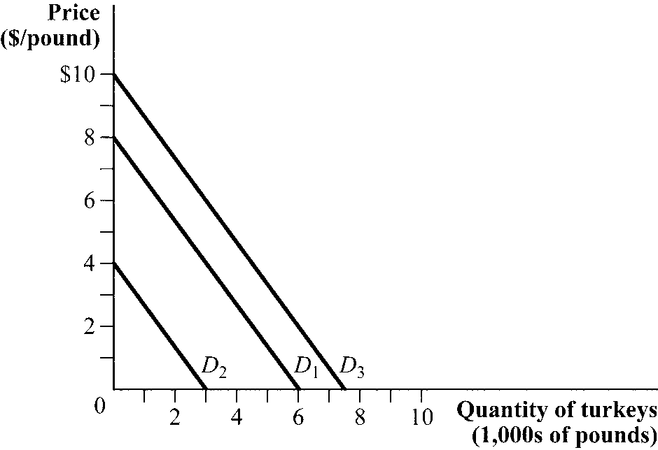

|  |  |  |
| --- | --- | --- |
| 11. | (Figure 2.1) Mathematically, the demand curve *D*1 is described by this equation: | |
| A) | *Q* = 0.75 – *P*. |
| B) | *Q* = 6 – 0.75*P*. |
| C) | *Q* = 8 – 1.33*P*. |
| D) | *P* = 6 – 8*P*. |

|  |  |  |
| --- | --- | --- |
| 12. | (Figure 2.1) A salmonella outbreak would shift the demand curve for turkey from *D*1 to _____, and a discovery that eating turkey reduces muscle fatigue in athletes would shift the demand curve for turkey from *D*1 to _____. | |
| A) | *D*2; *D*3 |
| B) | *D*3; *D*2 |
| C) | *D*3; *D*3 |
| D) | *D*2; *D*2 |

|  |  |  |
| --- | --- | --- |
| 13. | Which of the following will *not* cause demand for apples to increase or decrease? | |
| A) | a reduction in the price of apples. |
| B) | a reduction in the price of a complement for apples. |
| C) | an increase in income. |
| D) | a decrease in the number of consumers in the market. |

|  |  |  |  |  |  |  |  |  |
| --- | --- | --- | --- | --- | --- | --- | --- | --- |
| 14. | Which of the following statements is TRUE?   |  |  | | --- | --- | | I. | As more sellers enter a market, the supply of the product will increase. | | II. | If input prices increase, the supply of the product will be unaffected because firms pass the higher costs of production to consumers in the form of higher prices. | | III. | Firms respond to high prices for their product by offering a larger quantity for sale. | | |
| A) | I |
| B) | II and III |
| C) | I, II, and III |
| D) | I and III |

|  |  |  |
| --- | --- | --- |
| 15. | Genetically modified soybean seed is an example of a new technology that has increased productivity. As a result, this new technology _____ production costs and _____ the supply of soybeans. | |
| A) | raised; increased |
| B) | lowered; decreased |
| C) | lowered; increased |
| D) | raised; decreased |

|  |  |  |
| --- | --- | --- |
| 16. | Suppose that farmers can use their land to grow and sell soybeans and cotton. Cotton prices have risen. Farmers respond by producing _____ soybeans and _____ cotton. | |
| A) | more; less |
| B) | less; more |
| C) | more; more |
| D) | less; less |

Use the following to answer question 17:

**Figure 2.2**

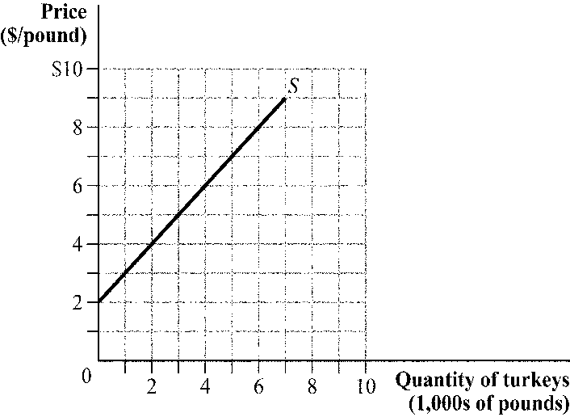

|  |  |  |
| --- | --- | --- |
| 17. | (Figure 2.2) If the price of turkey is $4 per pound, _____ pounds of turkey will be offered for sale; if the price of turkey is $7 per pound, _____ pounds of turkey will be offered for sale. | |
| A) | 3,000; 6,000 |
| B) | 0; 6,000 |
| C) | 2,000; 5,000 |
| D) | 1,000; 8,000 |

|  |  |  |
| --- | --- | --- |
| 18. | Suppose that the supply of a good is given by *Q* = –50 + 5*P*, where *Q* is the quantity supplied and *P* is the price measured in dollars per unit. This equation indicates that the quantity supplied increases by _____ units for every dollar increase in price. | |
| A) | 5 |
| B) | 45 |
| C) | 50 |
| D) | 55 |

Use the following to answer question 19:

**Figure 2.3**

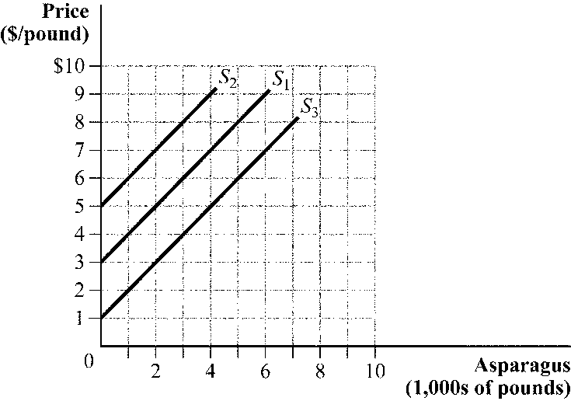

|  |  |  |
| --- | --- | --- |
| 19. | (Figure 2.3) An increase in quantity supplied could be indicated by: | |
| A) | the supply curve shifting from *S*1 to *S*2. |
| B) | the supply curve shifting from *S*1 to *S*3. |
| C) | movement up and along supply curve *S*1. |
| D) | the supply curve shifting from *S*3 to *S*2. |

|  |  |  |
| --- | --- | --- |
| 20. | If the supply curve is *QS* = 4*P* - 4, then the highest price at which no producer is willing to sell the good (i.e., the supply choke price) is: | |
| A) | 1 |
| B) | 4 |
| C) | 3 |
| D) | 2 |

Use the following to answer question 21:

**Figure 2.3**



|  |  |  |
| --- | --- | --- |
| 21. | (Figure 2.3) What could cause the supply curve to shift from *S*1 to *S*2? | |
| A) | an increase in the number of asparagus farmers |
| B) | poor weather conditions that reduce the asparagus harvest |
| C) | better fertilizers that lower the costs of production |
| D) | a decrease in the price of asparagus |

|  |  |  |
| --- | --- | --- |
| 22. | In the blackberry market, the quantity demanded is given by *QD* = 2,600 – 500*P*, and the quantity supplied is given by *QS* = –400 + 100*P*. What are the equilibrium price and equilibrium quantity? | |
| A) | $5 and 100 pounds |
| B) | $4.25 and 3,000 pounds |
| C) | $2.50 and 900 pounds |
| D) | $1.80 and 2,200 pounds |

|  |  |  |
| --- | --- | --- |
| 23. | If the price of crude oil increases and the number of people who own cars falls: | |
| A) | the equilibrium price of gasoline will increase and equilibrium quantity of gasoline will decrease. |
| B) | the equilibrium price of gasoline will decrease and equilibrium quantity of gasoline will be uncertain. |
| C) | the equilibrium price of gasoline will be uncertain and equilibrium quantity of gasoline will decrease. |
| D) | the equilibrium price of gasoline will be uncertain and equilibrium quantity of gasoline will increase. |

Use the following to answer questions 24-26:

**Figure 2.4**

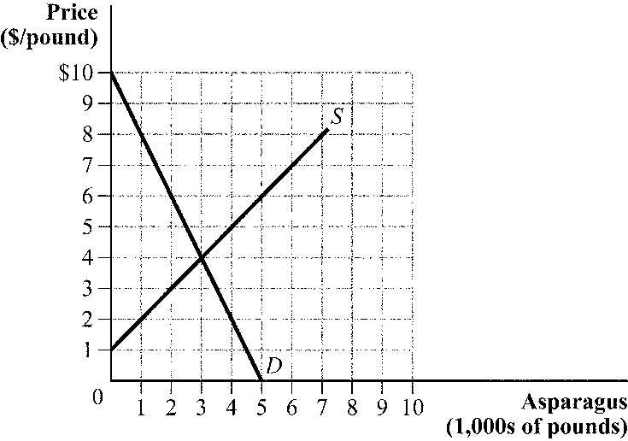

|  |  |  |
| --- | --- | --- |
| 24. | (Figure 2.4) At what price does the quantity demanded by consumers equal the quantity supplied by producers? | |
| A) | $5 |
| B) | $4 |
| C) | $1 |
| D) | $3 |

|  |  |  |
| --- | --- | --- |
| 25. | (Figure 2.4) At a price of $2, there is an excess: | |
| A) | supply of 4,000 pounds. |
| B) | supply of 3,000 pounds. |
| C) | demand of 3,000 pounds. |
| D) | demand of 1,000 pounds. |

|  |  |  |
| --- | --- | --- |
| 26. | (Figure 2.4) An excess supply of 3,000 pounds occurs at a price of: | |
| A) | $2. |
| B) | $5. |
| C) | $6. |
| D) | $8. |

|  |  |  |
| --- | --- | --- |
| 27. | Suppose that the demand and supply curves for green peas are given by *QD* = 10 – 8*P* and *QS* = 2*P*, where *P* is price per pound and *Q* is measured in thousands of pounds. If the price per pound of peas is $0.50, the market _____, so the price will _____. | |
| A) | has excess demand of 3,000 pounds; rise |
| B) | has excess supply of 1,000 pounds; fall |
| C) | is in equilibrium; remain unchanged |
| D) | has excess demand of 5,000 pounds; rise |

|  |  |  |
| --- | --- | --- |
| 28. | Suppose that the equilibrium price of blackberries is $3 per pound, and the price of black raspberries (a substitute for blackberries) increases. What happens in the market for blackberries? | |
| A) | An excess supply of blackberries at $3 per pound leads to an increase in quantity demanded and a decrease in quantity supplied. |
| B) | The demand curve for blackberries shifts to the right, reflecting an increase in both the equilibrium price and the quantity. |
| C) | An excess demand of blackberries at $3 per pound results in a new equilibrium price that is less than $3 per pound. |
| D) | The demand curve for blackberries decreases, reducing the equilibrium price and raising the equilibrium quantity. |

|  |  |  |
| --- | --- | --- |
| 29. | Suppose that we observe a decrease in the price of sunscreen and fewer people buying sunscreen. What could have caused this change? | |
| A) | a violation of the law of demand |
| B) | a tax on sunscreen manufacturers |
| C) | a new study documenting that the ingredients in sunscreen are linked to an increased risk of malignant melanoma, a dangerous form of skin cancer |
| D) | a new production process that reduces the costs of making sunscreen |

|  |  |  |
| --- | --- | --- |
| 30. | The Internet has made learning to play a musical instrument easier than ever, with thousands of Web sites offering free music lessons. What happens in the musical instruments market as a result of the availability of these free lessons? | |
| A) | The supply curve increases, pushing down the price. |
| B) | The demand curve shifts out, pushing up the price. |
| C) | The demand curve shifts out, which in turn causes the supply curve to increase. The overall effect on price is ambiguous. |
| D) | The price of musical instruments falls, causing an increase in the quantity demanded. |

Use the following to answer question 31:

**Figure 2.5**

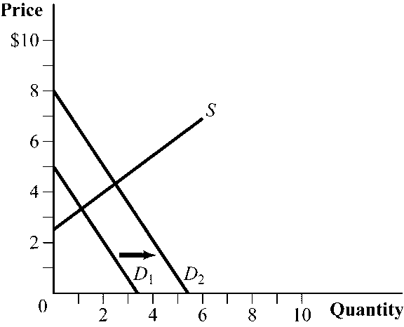

|  |  |  |  |  |  |  |  |  |  |  |
| --- | --- | --- | --- | --- | --- | --- | --- | --- | --- | --- |
| 31. | (Figure 2.5) Which of the following events could have caused the demand curve to shift?   |  |  | | --- | --- | | I. | The price of a substitute good decreased. | | II. | The price of a complement good increased. | | III. | The income of consumers increased. | | IV. | The number of buyers in the market increased. | | |
| A) | I, II, III, and IV |
| B) | III and IV |
| C) | II, III, and IV |
| D) | I and II |

|  |  |  |
| --- | --- | --- |
| 32. | The market for matsutake mushrooms is characterized by the following demand and supply equations: *QD* = 100 – *P* and *QS* = –50 + 2*P*, where *Q* is measured in pounds and *P* is measured in price per pound. If a new fertilizer increases the quantity supplied by 30 pounds at every price, the equilibrium price changes from _____ to _____. | |
| A) | $50; $70 |
| B) | $100; $30 |
| C) | $150; $110 |
| D) | $50; $40 |

|  |  |  |
| --- | --- | --- |
| 33. | An increase in input prices causes: | |
| A) | the market supply to shift inward, driving the equilibrium price downward. |
| B) | the market supply to shift outward, leading to a higher equilibrium price. |
| C) | the market supply to shift inward, driving the equilibrium price higher. |
| D) | the supply curve to decrease and the demand curve to decrease. |

|  |  |  |
| --- | --- | --- |
| 34. | In the market for oranges, we observe that the equilibrium price increased and the equilibrium quantity increased. What could have caused this change? | |
| A) | an increase in supply and a decrease in demand |
| B) | an increase in demand |
| C) | a decrease in supply |
| D) | an increase in supply |

|  |  |  |
| --- | --- | --- |
| 35. | Many video game makers in the early 1980s went out of business because: | |
| A) | a large increase in the supply of games lowered the price of video games so much that it made them unprofitable. |
| B) | a large decrease in the supply of games raised the price of video games so much that consumers stopped buying them. |
| C) | a large decrease in consumer demand lowered the price of video games so much that it made them unprofitable. |
| D) | a large increase in consumer demand raised the price of video games to the point that they were no longer affordable. |

|  |  |  |
| --- | --- | --- |
| 36. | What happens in the market for Blu-ray discs if the price of Blu-ray players falls? | |
| A) | The demand for Blu-ray discs increases. |
| B) | The quantity demanded of Blu-ray discs increases. |
| C) | The supply of Blu-ray discs increases. |
| D) | The demand and supply of Blu-ray discs increase. |

Use the following to answer question 37:

**Figure 2.6**

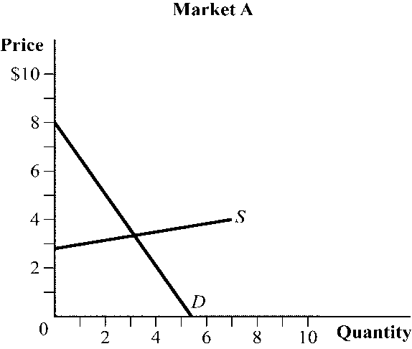 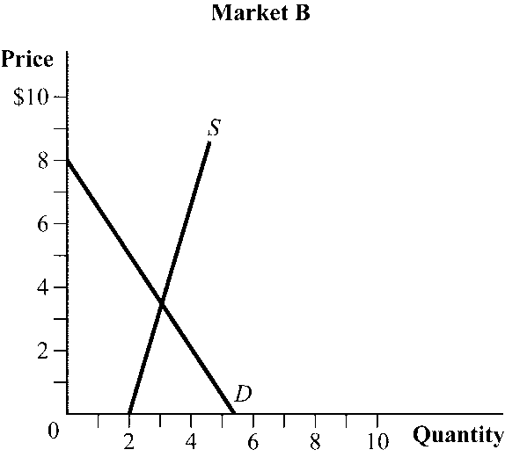

|  |  |  |
| --- | --- | --- |
| 37. | (Figure 2.6) Suppose that the demand curve in both markets shifts out by the same distance. The change in price will be larger in _____, and the change in quantity will be larger in _____. | |
| A) | market *A*; market *A* |
| B) | market *A*; market *B* |
| C) | market *B*; market *A* |
| D) | market *B*; market *B* |

|  |  |  |
| --- | --- | --- |
| 38. | Suppose a fall in consumer income drives down the demand for lobster while a record harvest increases supply. How would these changes affect the equilibrium price and quantity of lobsters? | |
| A) | Both equilibrium price and equilibrium quantity would decrease. |
| B) | The equilibrium price would fall, but the effect on the equilibrium quantity cannot be predicted. |
| C) | The equilibrium price would fall and the equilibrium quantity would increase. |
| D) | The equilibrium quantity would increase, but the effect on price cannot be predicted. |

|  |  |  |
| --- | --- | --- |
| 39. | A decrease in both demand and supply will cause a(n) _____ equilibrium price and a(n) _____ equilibrium quantity. | |
| A) | uncertain effect on; decrease in |
| B) | increase in; decrease in |
| C) | increase in; uncertain effect on |
| D) | decrease in; uncertain effect on |

|  |  |  |
| --- | --- | --- |
| 40. | If a 10% increase in the price of pork reduces quantity demanded by 7%, the price elasticity of demand is: | |
| A) | –1.43. |
| B) | –0.14. |
| C) | –3.0. |
| D) | –0.70. |

|  |  |  |
| --- | --- | --- |
| 41. | Consumers are particularly price-responsive when: | |
| A) | it is difficult to substitute across suppliers and prices are high. |
| B) | prices are low and they have little time to change their consumption patterns. |
| C) | a product has many substitutes and they have a long time to adjust their consumption. |
| D) | there are few substitute goods available for a product, and they have a short time horizon to adjust their consumption. |

|  |  |  |
| --- | --- | --- |
| 42. | In market *A*, a 4% increase in price reduces quantity demanded by 2%. In market *B*, a 3% increase in price reduces quantity demanded by 4%. The price elasticity of demand in market *A* and market *B* are considered_____ and _____, respectively. | |
| A) | elastic; inelastic |
| B) | inelastic; elastic |
| C) | perfectly elastic; unit elastic |
| D) | unit elastic; perfectly inelastic |

Use the following to answer question 43:

**Figure 2.7**

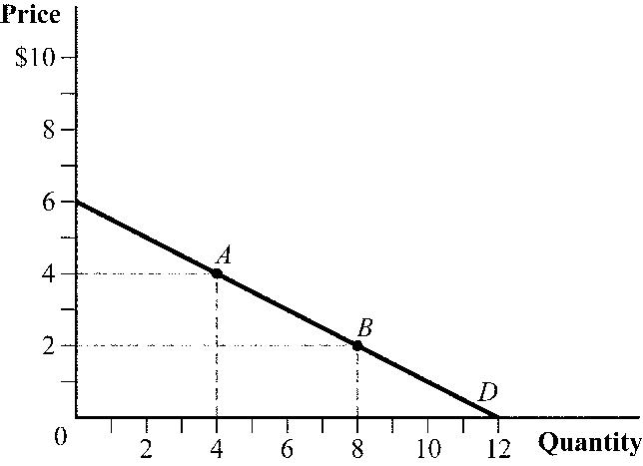

|  |  |  |
| --- | --- | --- |
| 43. | (Figure 2.7) What is the price elasticity of demand at point *A* and point *B*? | |
| A) | point *A* = –2.0, point *B* = –0.50 |
| B) | point *A* = –0.50, point *B* = –0.50 |
| C) | point *A* = –1.0, point *B* = –2.0 |
| D) | point *A* = –2.5, point *B* = –1.5 |

Use the following to answer question 44:

**Figure 2.8**

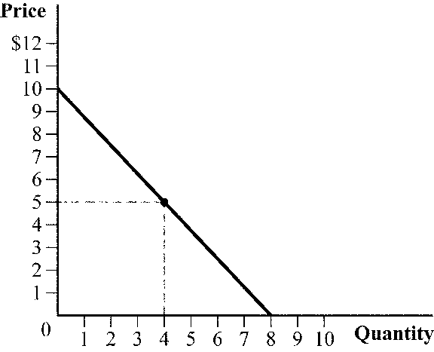

|  |  |  |  |  |  |  |  |  |  |  |
| --- | --- | --- | --- | --- | --- | --- | --- | --- | --- | --- |
| 44. | (Figure 2.8) Which of the following statements is TRUE?   |  |  | | --- | --- | | I. | The price elasticity of demand is less than 1 in absolute value at prices less than $5. | | II. | The price elasticity of demand is elastic at prices above $5. | | III. | The price elasticity of demand is negative infinity at a price of $0. | | IV. | At $5, the price elasticity of demand is perfectly inelastic. | | |
| A) | III only |
| B) | II and IV |
| C) | I, II, III, and IV |
| D) | I and II |

Use the following to answer question 45:

**Figure 2.9**

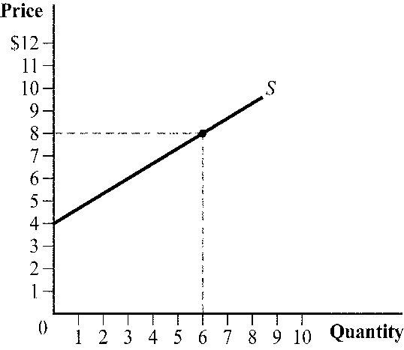

|  |  |  |
| --- | --- | --- |
| 45. | (Figure 2.9) The price elasticity of supply at $4 is: | |
| A) | 0. |
| B) | 4. |
| C) | infinity. |
| D) | 0.67. |

|  |  |  |
| --- | --- | --- |
| 46. | The demand curve for a product is *Q* = 50 – 0.5*P*. What is the price elasticity of demand at a price of $60? | |
| A) | –1.50 |
| B) | –1.0 |
| C) | –0.80 |
| D) | –0.25 |

|  |  |  |
| --- | --- | --- |
| 47. | The inverse demand curve for eggs is *P* = 20 – 0.25*Q*. What is the price elasticity of demand at *P* = $4? | |
| A) | –0.45 |
| B) | –2.0 |
| C) | –4.0 |
| D) | –0.25. |

Use the following to answer question 48:

**Figure 2.10**

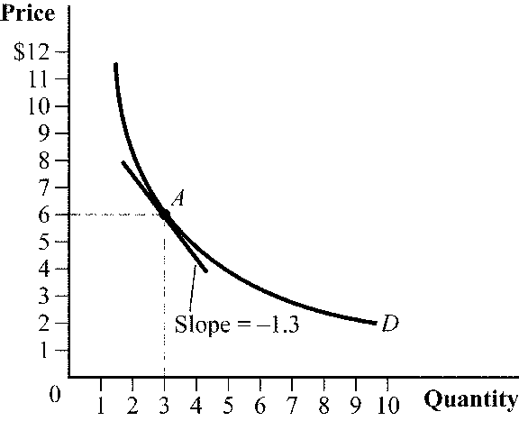

|  |  |  |
| --- | --- | --- |
| 48. | (Figure 2.10) What is the price elasticity of demand at point *A*? | |
| A) | –2.6 |
| B) | –1.54 |
| C) | –0.7 |
| D) | –3.2 |

Use the following to answer question 49:

**Figure 2.11**

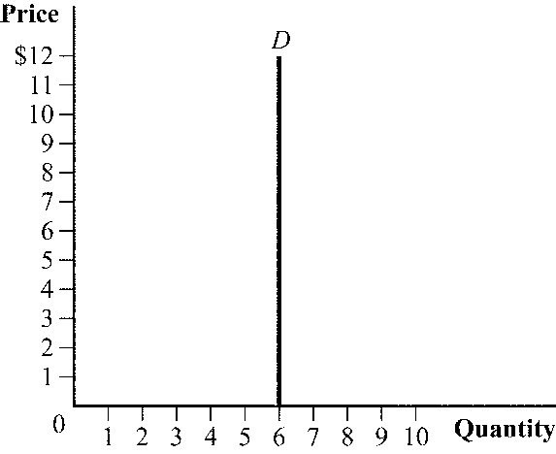

|  |  |  |  |  |  |  |  |  |
| --- | --- | --- | --- | --- | --- | --- | --- | --- |
| 49. | (Figure 2.11) Which of the following statements is TRUE regarding the figure?   |  |  | | --- | --- | | I. | The price elasticity of demand is . | | II. | The demand curve is perfectly inelastic. | | III. | An increase in price has no effect on quantity demanded. | | |
| A) | I and III |
| B) | I, II, and III |
| C) | II and III |
| D) | II |

|  |  |  |
| --- | --- | --- |
| 50. | Suppose that the supply of oil to Pittsburgh, Pennsylvania, is perfectly elastic. If more people move to Pittsburgh because of its great football and hockey teams, what happens to the equilibrium price and quantity of oil in Pittsburgh? | |
| A) | Both the equilibrium price and the quantity increase. |
| B) | The equilibrium price increases, but the equilibrium quantity is unchanged. |
| C) | The equilibrium quantity increases, but the equilibrium price is unchanged. |
| D) | Both the equilibrium price and the quantity are unchanged. |

|  |  |  |
| --- | --- | --- |
| 51. | The price of baseball tickets increased by 5%, leading to a 3% decrease in the number of tickets sold. Given this specific situation, total expenditures on baseball tickets: | |
| A) | fell. |
| B) | stayed the same. |
| C) | increased. |
| D) | could have increased, decreased, or stayed the same depending on the price elasticity of demand. |

|  |  |  |
| --- | --- | --- |
| 52. | An increase in the price of computer chips causes a decrease in the total revenue of computer chip manufacturers. The price elasticity of demand for computer chips is: | |
| A) | positive and elastic. |
| B) | inelastic. |
| C) | elastic. |
| D) | positive and inelastic. |

Use the following to answer question 53:

**Figure 2.12**

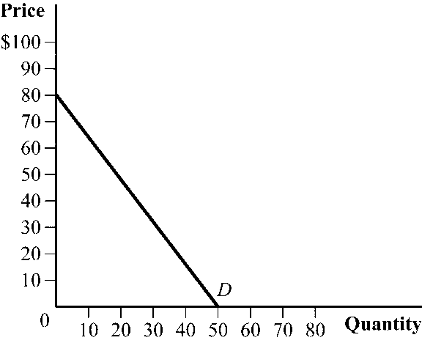

|  |  |  |
| --- | --- | --- |
| 53. | (Figure 2.12) As the price of the product rises from $0 to $40, what happens to total expenditures? | |
| A) | Total expenditures increase, reaching a maximum at a price of $40. |
| B) | Total expenditures remain unchanged. |
| C) | Total expenditures decrease, reaching a minimum at a price of $40. |
| D) | Total expenditures first increase and then decrease, as price approaches the midpoint of the demand curve. |

|  |  |  |
| --- | --- | --- |
| 54. | If the inverse demand curve for a good is given by *P* = 100 – 4*Q*, the price elasticity of demand is elastic at a price of _____ and inelastic at a price of _____. | |
| A) | $40; $60 |
| B) | $60; $50 |
| C) | $55; $35 |
| D) | $35; $30 |

|  |  |  |
| --- | --- | --- |
| 55. | The income elasticity of demand for dental services is 2.40, and the income elasticity of demand for nursing homes is 0.90. Based on these estimates, dental services are a(n) _____ and nursing home care is a(n) _____. | |
| A) | luxury good; normal good |
| B) | normal good; inferior good |
| C) | inferior good; luxury good |
| D) | normal good; luxury good |

|  |  |  |
| --- | --- | --- |
| 56. | If a 5% increase in income increases quantity demanded by 4%, the income elasticity of demand is: | |
| A) | 1.25. |
| B) | 0.80. |
| C) | 2.0. |
| D) | 0.02. |

|  |  |  |
| --- | --- | --- |
| 57. | Suppose that the cross-price elasticity of demand for movie popcorn with respect to movie tickets is –0.75. If the price of movie tickets rises by 4%, the quantity demanded of movie popcorn will: | |
| A) | fall by 18.75%. |
| B) | fall by 30%. |
| C) | rise by 3%. |
| D) | fall by 3%. |

|  |  |  |
| --- | --- | --- |
| 58. | On some days Gus makes his own salad for lunch, preferring to use either iceberg or romaine lettuce, topped off with lots of fresh tomatoes. The cross-price elasticity of demand for iceberg lettuce with respect to romaine lettuce is _____, and the cross-price elasticity of demand for iceberg lettuce with respect to tomatoes is _____. | |
| A) | positive; negative |
| B) | negative; positive |
| C) | zero; positive |
| D) | negative; zero |

|  |  |
| --- | --- |
| 59. | List the four basic assumptions of the supply and demand model. |

|  |  |
| --- | --- |
| 60. | Two firms, Boeing and Airbus, produce large commercial airplanes. Boeing and Airbus have different flight control systems, with many pilots preferring one system to the other. Also, the Airbus A380, at $375.3 million, has a double-deck design that can hold up to 840 passengers. The Boeing 747 can hold up to 568 passengers, and it sells for $317.5 million. What key assumptions of the supply and demand model are violated in the large commercial airplane market? |

|  |  |
| --- | --- |
| 61. | Write out an equation for a downward-sloping linear demand curve. Next, graph this demand curve on a well-labeled diagram, showing the numerical values of the vertical and horizontal intercepts. |

|  |  |  |  |  |  |  |  |
| --- | --- | --- | --- | --- | --- | --- | --- |
| 62. | Suppose that the demand for a product is given by *Q* = 25 – 0.25*P*.   |  |  | | --- | --- | | a. | Solve for the inverse demand curve. | | b. | Graph the inverse demand curve, showing the numerical values for the vertical and the horizontal intercepts. | | c. | If the product's price is $105 per unit, how many units will consumers be willing to buy? | |

Use the following to answer question 63:

**Figure 2.13**

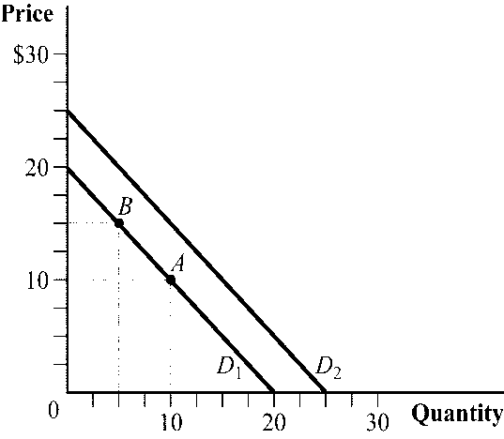

|  |  |  |  |  |  |
| --- | --- | --- | --- | --- | --- |
| 63. | (Figure 2.13) Use the figure to answer the next set of questions.   |  |  | | --- | --- | | a. | List the most common factors affecting demand that could cause the movement from point *A* to point *B.* | | b. | List the most common factors affecting demand that could cause the demand curve to shift out from *D*1 to *D*2. | |

|  |  |
| --- | --- |
| 64. | Determine the equation for both normal and inverse demand equations using the information in the associated graph. |

|  |  |  |  |  |  |  |  |
| --- | --- | --- | --- | --- | --- | --- | --- |
| 65. | The supply curve of rubber balls is given by *Q* = 100*P* – 10.   |  |  | | --- | --- | | a. | What happens to the quantity supplied of rubber balls if the price of rubber balls increases by $1? | | b. | What is the equation for the inverse supply curve? | | c. | Graph the supply curve of rubber balls, showing the quantity supplied at prices of $0.10 and $0.60. | |

|  |  |
| --- | --- |
| 66. | What is the difference between a change in supply and a change in quantity supplied? |

|  |  |
| --- | --- |
| 67. | The normal supply curve is *QS* = 12*P* – 20. What is the inverse supply curve? |

|  |  |
| --- | --- |
| 68. | According to the nearby figure, what is the equation for the normal supply curve? Now assume that the price of raw materials for this product falls, leading suppliers to offer three additional units at every price. What is the equation for the new supply curve? |

|  |  |
| --- | --- |
| 69. | The inverse supply equation for clay pots is *P* = 0.5*Q S*+ 1; the inverse demand equation is *P* = –2*QD* + 15. Quantity is in thousands of units. What are the normal supply equation, the normal demand equation, and the resulting equilibrium price and quantity? |

|  |  |  |  |  |  |
| --- | --- | --- | --- | --- | --- |
| 70. | In the market for cotton, the quantity demanded and quantity supplied are expressed mathematically as *QD* = 400 – 250*P* and *QS* = 250*P* – 100, where *P* is the price per pound of cotton.   |  |  | | --- | --- | | a. | What are the equilibrium price and equilibrium quantity? | | b. | Graph the demand and supply curves, and include your answers from part a. | |

|  |  |  |  |  |  |  |  |
| --- | --- | --- | --- | --- | --- | --- | --- |
| 71. | Suppose that the demand and supply curves for a good are given by *QD* = 1,000/*P* and *QS* = 10*P*.   |  |  | | --- | --- | | a. | What are the equilibrium price and equilibrium quantity? | | b. | Explain what is happening in the market at a price of $2. | | c. | Explain what is happening in the market at a price of $20. | |

|  |  |  |  |  |  |
| --- | --- | --- | --- | --- | --- |
| 72. | Suppose that the demand and supply curve for a good are given by *QD* = 90 – *P* and *QS* = 4*P* – 10.   |  |  | | --- | --- | | a. | What are the equilibrium price and equilibrium quantity? | | b. | At what price is there an excess demand of 50 units? | |

|  |  |  |  |  |  |  |  |  |  |
| --- | --- | --- | --- | --- | --- | --- | --- | --- | --- |
| 73. | How are the following events likely to affect equilibrium price and equilibrium quantity in the maple syrup market?   |  |  | | --- | --- | | a. | The price of pancake mix doubles. | | b. | Academic scientists claim that consuming maple syrup raises good cholesterol. | | c. | Sap streak disease spreads throughout North America, killing tens of thousands of maple trees. | | d. | The price of Aunt Jemima pancake syrup (made with corn syrup, not maple syrup) increases. | |

|  |  |  |  |  |  |
| --- | --- | --- | --- | --- | --- |
| 74. | The market for cod liver oil pills is characterized by the following demand and supply equations: *QD* = 100 – 4*P* and *QS* = –20 + 2*P*, where *P* is the price per bottle and *Q* is the quantity of bottles.   |  |  | | --- | --- | | a. | What are the equilibrium price and quantity? | | b. | If consumers want to purchase 60 more bottles at any given price, what are the new equilibrium price and quantity? | |

|  |  |  |  |  |  |  |  |  |  |
| --- | --- | --- | --- | --- | --- | --- | --- | --- | --- |
| 75. | Using well-labeled supply and demand curves, show how the following events will affect the market for the metal lead.   |  |  | | --- | --- | | a. | A large deposit of lead is found in Australia. | | b. | Millions of Chinese who were recently lifted out of poverty buy new cars that use lead acid batteries. | | c. | The EPA bans the use of lead ammunition because of environmental concerns. | | d. | A new production technology reduces the cost of removing lead from ore. | |

|  |  |
| --- | --- |
| 76. | According to political journalist Michael Kinsley, “The price of oil shoots up; we start using less; reduced demand sends the price down; we start using more; pretty soon it's shooting up again.” Explain whether you agree or disagree with Kinsley's assessment of oil markets. |

|  |  |  |  |  |  |  |  |  |  |
| --- | --- | --- | --- | --- | --- | --- | --- | --- | --- |
| 77. | In each of the following cases, predict what will happen to the equilibrium price and quantity.   |  |  | | --- | --- | | a. | More sellers enter the market and consumer income decreases. The good is a normal good. | | b. | The price of a substitute good increases and sellers' options in other markets become less profitable. | | c. | A drought reduces the cotton harvest and cotton clothing falls out of favor with consumers. | | d. | The price of inputs in production rises and the price of a complement good falls. | |

|  |  |  |  |  |  |  |  |
| --- | --- | --- | --- | --- | --- | --- | --- |
| 78. | In the market for good *X*, demand is *QD* = 6,000 – 0.8*P* and supply is *QS* = 0.4*P* – 300.   |  |  | | --- | --- | | a. | What are the equilibrium price and quantity? | | b. | Solve for the inverse demand and inverse supply equations. | | c. | Suppose that an increase in consumer income makes consumers willing to pay $500 more per unit of good *X*. Also, a technological breakthrough in production makes firms willing to sell good *X* for $500 less per unit. What are the new equilibrium price and quantity? | |

|  |  |
| --- | --- |
| 79. | Assume that the demand equation for exercise watches, such as the Fitbit, is *QD* = 2,200 – 15*P* and the supply equation is *QS* = 15*P* – 800. Calculate the equilibrium price and equilibrium quantity in this market. |

|  |  |
| --- | --- |
| 80. | Assume that the demand equation for exercise watches, such as the Fitbit, is *QD* = 2,200 – 15*P* and the supply equation is *QS* = 15*P* – 800. After a favorable study shows that using exercise watches significantly reduces users' weights, quantity demanded increases by 300 at every price. The new equilibrium price will be _____ and the new equilibrium quantity will be _____. |

|  |  |  |  |  |  |
| --- | --- | --- | --- | --- | --- |
| 81. | Suppose the inverse demand for a good is given by *P* = 6 – *Q*.   |  |  | | --- | --- | | a. | What is the price elasticity of demand at *P* = $3? Is demand elastic at this price? | | b. | If consumers are willing to pay $2 more per unit, what is the price elasticity of demand at *P* = $3? Is demand elastic at this price? | |

|  |  |  |  |  |  |  |  |  |  |
| --- | --- | --- | --- | --- | --- | --- | --- | --- | --- |
| 82. | Answer the following questions about price elasticity of demand.   |  |  | | --- | --- | | a. | The price elasticity of demand for MLB tickets is –0.50. What happens to the quantity of tickets sold if ticket prices rise by 5%? | | b. | The price elasticity of demand for fried chicken is –1.12. What happens to expenditures on fried chicken following a price increase? | | c. | Suppose the demand for insulin is given by *QD* = 1,000. What is the price elasticity of demand at *P* = $100? | | d. | What will happen to the price elasticity of demand if there are more substitute goods available? | |

|  |  |  |  |  |  |  |  |
| --- | --- | --- | --- | --- | --- | --- | --- |
| 83. | The demand and supply curves for a good are given by *QD* = 50 – 2*P* and *QS* = *P –* 1.   |  |  | | --- | --- | | a. | Calculate the price elasticity of demand at the equilibrium price. | | b. | Calculate the price elasticity of supply at the equilibrium price. | | c. | What would happen to consumer expenditures on the good if firms must pay higher prices for their inputs in production? | |

|  |  |  |  |  |  |  |  |
| --- | --- | --- | --- | --- | --- | --- | --- |
| 84. | Consider the following questions on elasticity.   |  |  | | --- | --- | | a. | If a 3% increase in income leads to a 1% increase in the quantity purchased, what is the income elasticity of demand? Is the good an inferior good? | | b. | The price of good *Y* decreases by 15% and the quantity sold of good *X* increases by 4%. What is the cross-price elasticity of demand for good *X* with respect to good *Y*? How are good *X* and good *Y* related? | | c. | The demand equation is *QD* = 15 – *P*. What is the price elasticity of demand at *P* = $6? | |

|  |  |
| --- | --- |
| 85. | Suppose your company is faced with the following demand curve: *QD* = 600 – 100*P*. The price elasticity of demand, *ED,* at a price of $5 equals _____, and the price elasticity of demand, *ED*, at a price of $1 equals _____. |

|  |  |
| --- | --- |
| 86. | Please refer to the nearby figure. In the market for asparagus, consumer income rises by 10%, leading to the new demand curve: *QD* = –0.5*P* + 6.5. What is the income elasticity of demand between the old and new equilibrium prices? |

|  |  |
| --- | --- |
| 87. | The inverse supply equation for clay pots is *P* = 0.5*QS* + 1; the inverse demand equation is *P* = –2*QD* + 15. Quantity is in thousands of units. Which is more elastic at a price of $3.80, demand or supply? Round your answers to four decimal places. |

|  |  |
| --- | --- |
| 88. | Assume that the elasticity of supply is 1.59. If the price of the product increases by 10%, by how much do we expect the quantity supplied to increase? |

|  |  |  |
| --- | --- | --- |
| 89. | To test whether the law of demand holds using calculus, you should: | |
| A) | take the partial derivative of quantity demanded *QD* with respect to *P* and conclude that the law of demand holds if this derivative is positive at the market price. |
| B) | take the partial derivative of quantity demanded *QD* with respect to *P* and conclude that the law of demand holds if this derivative is negative at the market price. |
| C) | take the derivative of *P* with respect to quantity demanded *QD* and conclude that the law of demand holds if this derivative is positive at the market price. |
| D) | take the derivative of *P* with respect to quantity demanded *QD* and conclude that the law of demand holds if this derivative is negative at the market price. |

|  |  |  |
| --- | --- | --- |
| 90. | Suppose that the market demand curve for sunflowers is a function of the price of sunflowers, the price of roses, and income. If the partial derivative of quantity demanded of sunflowers with respect to the price of roses is negative, sunflowers and roses are: | |
| A) | substitutes. |
| B) | complements. |
| C) | normal goods. |
| D) | inferior goods. |

|  |  |  |
| --- | --- | --- |
| 91. | Suppose that the market demand curve for sunflowers is a function of the price of sunflowers, the price of roses, and income. If the partial derivative of quantity demanded of sunflowers with respect to income is negative: | |
| A) | sunflowers are normal goods. |
| B) | roses are normal goods. |
| C) | sunflowers are inferior goods. |
| D) | roses are inferior goods. |

|  |  |  |
| --- | --- | --- |
| 92. | Suppose that the market demand curve for cauliflower is a function of the price of cauliflower, the price of broccoli, and income. If the partial derivative of quantity demanded of cauliflower with respect to the price of broccoli is positive, cauliflower and broccoli are: | |
| A) | substitutes. |
| B) | complements. |
| C) | normal goods. |
| D) | inferior goods. |

|  |  |
| --- | --- |
| 93. | Suppose that watermelon, with price *PW*, and barbecue sauce are related goods. The expanded demand curve for barbecue sauce, then, is . Suppose that  *PW* is $5 per watermelon. Use calculus to determine whether watermelon is complementary or a substitute for barbecue sauce. |

|  |  |  |
| --- | --- | --- |
| 94. | Suppose that the market demand curve for cauliflower is a function of the price of cauliflower, the price of broccoli, and income. If the partial derivative of quantity demanded of cauliflower with respect to income is positive: | |
| A) | neither cauliflower nor broccoli is a normal good. |
| B) | cauliflower and broccoli are both normal goods. |
| C) | broccoli is a normal good. |
| D) | cauliflower is a normal good. |

|  |  |
| --- | --- |
| 95. | Suppose that the extended market demand curve for maple syrup can be expressed as , where *Pp* is the price of pancake batter and *I* is income.  a. Use calculus to argue whether pancake batter is a substitute or complement to maple syrup.  b. Use calculus to argue whether maple syrup is a normal or an inferior good. |

|  |  |
| --- | --- |
| 96. | Suppose that the market demand and supply curves for chocolate ice cream are represented by the following equations:  *QD* = 10,000 – 50*P*  *QS* = –200 + 40*P*  where *QD* is the quantity demanded, *QS* is the quantity supplied, and *P* is the price.  a. Show that the law of demand holds using calculus.  b. Show that the law of supply holds using calculus. |

|  |  |
| --- | --- |
| 97. | Suppose that the market demand and supply curves for granola bars are represented by the following equations:  *QD* = 7,000 – 120*P*  *QS* = –50 + 20*P*  where *QD* is the quantity demanded, *QS* is the quantity supplied, and *P* is the price.  a. Show that the law of demand holds using calculus.  b. Show that the law of supply holds using calculus. |

|  |  |
| --- | --- |
| 98. | Suppose that the extended supply curve for children's books can be expressed as , where *Pp* is the price of colored paper. Using calculus, determine whether quantity supplied of children's books increases or decreases as the price of colored paper increases. |

|  |  |  |
| --- | --- | --- |
| 99. | To test whether the law of supply holds using calculus, you should: | |
| A) | take the partial derivative of quantity supplied *QS* with respect to *P* and conclude that the law of supply holds if this derivative is positive at the market price. |
| B) | take the partial derivative of quantity supplied *QS* with respect to *P* and conclude that the law of supply holds if this derivative is negative at the market price. |
| C) | take the derivative of *P* with respect to quantity supplied *QS* and conclude that the law of supply holds if this derivative is positive at the market price. |
| D) | take the derivative of *P* with respect to quantity supplied *QS* and conclude that the law of supply holds if this derivative is negative at the market price. |

|  |  |  |
| --- | --- | --- |
| 100. | In the standard model, we expect the partial derivative of quantity supplied with respect to input price to be: | |
| A) | positive. |
| B) | negative. |
| C) | either positive or negative. |
| D) | The correct answer is uncertain without more information. |

|  |  |  |
| --- | --- | --- |
| 101. | Suppose the demand for fabric softener can be described as *QD* = 1,000 – *P* +0.01*I*, where *QD* is the quantity of fabric softener demanded, *P* is the price of fabric softener, and *I* is income. Suppose that income is initially 1,000, but it falls to 800. The *new* equation for the demand for fabric softener is: | |
| A) | 800 – *P* + 0.01*I*, and demand has shifted to the left. |
| B) | 800 – *P* + 0.01*I*, and demand has shifted to the right. |
| C) | 1,080 – *P* and, demand has shifted to the left. |
| D) | 1,080 – *P* and, demand has shifted to the right. |

|  |  |  |
| --- | --- | --- |
| 102. | Suppose the demand for fabric softener can be described as *QD* = 800 – *P* – *PD*, where *QD* is the quantity of fabric softener demanded, *P* is the price of fabric softener, and *PD* is the price of laundry detergent. Suppose that the price of detergent is initially 10 but increases to 15. The *new* equation for the demand of fabric softener is: | |
| A) | 785 – *P*,and demand has shifted to the left. |
| B) | 785 – *P*,and demand has shifted to the right. |
| C) | 815 – *P*,and demand has shifted to the left. |
| D) | 815 – *P*,and demand has shifted to the right. |

|  |  |  |
| --- | --- | --- |
| 103. | Suppose that the inverse demand curve for energy drinks can be expressed as . The price elasticity of demand at a quantity of 25 is: | |
| A) | –0.5. |
| B) | 0.5. |
| C) | –2. |
| D) | 2. |

|  |  |  |
| --- | --- | --- |
| 104. | For an elastic demand function, the derivative of the revenue function with respect to price is: | |
| A) | positive. |
| B) | negative. |
| C) | zero. |
| D) | infinite. |

|  |  |
| --- | --- |
| 105. | Suppose the demand for baby shoes in a small town is described by the following equation:  *Q* = 50 – 2*P*  where *Q* is the quantity of baby shoes demanded and *P* is the average price of a pair of baby shoes.  a. What is the price elasticity of demand for baby shoes when the price is $15? Use calculus to show the answer.  b. What is the price elasticity of demand for baby shoes when the price is $10? Use calculus to show the answer. |

|  |  |
| --- | --- |
| 106. | Suppose that the inverse demand curve for a well-known sports car can be expressed as , where price is in dollars and quantity is in numbers of cars.  a. What is the price elasticity of demand at a quantity of 100?  b. Is the demand for these sports cars elastic or inelastic? |

|  |  |
| --- | --- |
| 107. | Suppose that the inverse demand curve for a new laptop computer can be expressed as , where price is in dollars and quantity is in number of laptops.  a. What is the price elasticity of demand at a quantity of 625?  b. Is the demand for these laptops elastic or inelastic? |

|  |  |
| --- | --- |
| 108. | Suppose that the demand curve for a new product can be expressed as *QD* = 900 – 3*P.* At what price and quantity is total expenditure maximized? |

|  |  |
| --- | --- |
| 109. | Suppose that the demand curve for scissors can be expressed as *QD* = 600 – 0.5*P.* At what price and quantity is total expenditure maximized? |

**Answer Key**

|  |  |
| --- | --- |
| 1. | A |
| 2. | C |
| 3. | C |
| 4. | C |
| 5. | A |
| 6. | D |
| 7. | B |
| 8. | A |
| 9. | D |
| 10. | D |
| 11. | B |
| 12. | A |
| 13. | A |
| 14. | D |
| 15. | C |
| 16. | B |
| 17. | C |
| 18. | A |
| 19. | C |
| 20. | A |
| 21. | B |
| 22. | A |
| 23. | C |
| 24. | B |
| 25. | C |
| 26. | C |
| 27. | D |
| 28. | B |
| 29. | C |
| 30. | B |
| 31. | B |
| 32. | D |
| 33. | C |
| 34. | B |
| 35. | A |
| 36. | A |
| 37. | C |
| 38. | B |
| 39. | A |
| 40. | D |
| 41. | C |
| 42. | B |
| 43. | A |
| 44. | D |
| 45. | C |
| 46. | A |
| 47. | D |
| 48. | B |
| 49. | C |
| 50. | C |
| 51. | C |
| 52. | C |
| 53. | A |
| 54. | C |
| 55. | A |
| 56. | B |
| 57. | D |
| 58. | A |
| 59. | 1. We examine how supply and demand interact in a single market.  2. All goods bought and sold in the market are homogeneous.  3. All goods in the market sell for the same price.  4. There are many producers and consumers in the market. |
| 60. | Three assumptions are violated. First, Boeing and Airbus produce different types of airplanes. Second, Boeing and Airbus planes sell for different prices. Third, there are only two producers of large commercial airplanes, not many. |
| 61. | Answers will vary, but the general form of a demand curve is given by *Q* = *a – bP*, where parameter *a* is a positive constant and parameter *b* is a positive constant. The horizontal intercept is *a*, and the vertical intercept is *a/b*.  One example of a demand curve is *Q* = 100 – 2*P*. The demand curve intersects the quantity axis (horizontal intercept) at 100 and intersects the price axis (vertical intercept) at 50. |
| 62. | a. Solve the demand equation for these values:  0.25*P* = 25 – *Q*  *P* = 100 – 4*Q*  b.     |  |  | | --- | --- | | c. | *Q* =25 – 0.25(105) = –1.25, so consumers are not willing to buy any of the product. | |
| 63. | a. A rise in the good's price is the only factor that could cause movement up and along a given demand curve.  b. If there is a change in the number of consumers, in consumer income, in consumer tastes, or in the price of other goods, the demand curve shifts out. |
| 64. | First, since the graph shows a linear demand curve, the generic form of the equation will be *y* = *mx + b*. To find the inverse demand equation, first replace *y* with *P* and *x* with *QD* to get *P* = *mQD* + *b*. The *y*-intercept, *b*, will be the price when quantity demanded is zero, which we determine from the graph to be $6, so *P* = *mQD* + 6. Finally, slope is the change in price due to a change in quantity for the inverse demand curve, which in this case is –6/12, or –0.5. Plugging this into the equation leads to the inverse demand equation of *P* = –0.5*QD* + 6. To find the normal demand equation, solve the inverse demand equation for *QD*:  *P* = –0.5*QD* + 6  *P* – 6 = –0.5*QD*  *QD* = –2*P* + 12 |
| 65. | a. For every $1 increase in price, the quantity supplied of rubber balls increases by 100.  b. –100*P* = –10 – *Q*  *P* = 0.10 + *Q*/100  c. |
| 66. | A change in supply refers to the supply curve shifting position, setting up an entirely new relationship between price and quantity supplied. A change in quantity supplied is a movement along a supply curve that is caused by a change in the product's price. |
| 67. | To find the inverse supply curve, solve the normal supply equation for *P*.  *QS* = 12*P* – 20  12*P* = 20 + *QS*  *P* = 0.083*QS* + 1.67 |
| 68. | To find the original supply equation, start with *y* = *mx + b* since the supply curve is linear. Replace *y* with *P* and *x* with *QS* to get *P* = *mQS* + *b*. The *y*-intercept in this case will be the price when quantity supplied equals zero, or $4. The slope will be D*P/*D*QS*,or (8 – 4)/(6 – 0) = 0.67. Plugging the *y*-intercept and slope into *P* = *mQS* + *b* yields *P* = 0.67*QS* + 4. Solve for *QS* to find the normal supply equation: *QS* = 1.5*P* – 6.  If the price of raw materials falls, leading suppliers of this product to offer three additional units at every price, the supply curve will shift to the right by three units, leading to a new normal supply equation with a *y*-intercept that is three units lower than the original equation: *QS* = 1.5*P* – 3. |
| 69. | Solving *P* = 0.5*QS* + 1 for *QS* leads to *QS* = 2*P* –2; solving *P* = –2*QD* + 15 for *QD* yields *QD* = –0.5*P* + 7.5.  Set *QD* = *QS*  –0.5*P* + 7.5 = 2*P* – 2  2.5*P* =9.5  *P* = $3.80  *Q* =2(3.80) – 2 = 5,600 |
| 70. | a. *QD* = *QS*  400 – 250*P*=250*P* – 100  –500*P* = –500  *P* = $1  *QD* = 400 – 250 (1) = 150  *QS* = 250(1) – 100 = 150  *P* = 1; *Q* =150  b. |
| 71. | a. *QD* = *QS*  1,000/*P* = 10*P*.  *P*2= 100  *P* = 10  *QD* = 1,000/(10) = 100  *QS* = 10(10) = 100  *P* = 10; *Q* =100  b. There is excess demand of 480 units.  At *P*=$2, *QD* = 1,000/(2) = 500 and *QS* = 10(2) = 20, giving an excess demand of 480.  c. There is an excess supply of 150 units.  At *P* =$20, *QD* = 1,000/(20) = 50 and *QS* = 10(20) = 200, giving an excess supply of 150. |
| 72. | a. *QD* = *QS*  90 – *P* = 4*P* – 10.  –5*P* = –100  *P* = $20  *QD* = 90 – 20 = 70  *QS* = 4(20) – 10 = 70  *P* = 20; *Q* =70  b. At *P* = 10, *QD* = 90 – 10 = 80 and *QS* = 4(10) – 10 = 30, giving excess demand of 50. |
| 73. | |  |  | | --- | --- | | a. | A rise in the price of a complement will cause a decrease in demand, leading to a decrease in the equilibrium price and quantity. | | b. | A positive change in consumer tastes will cause an increase in demand, leading to an increase in the equilibrium price and quantity. | | c. | The production of maple syrup will be reduced (a decrease in supply), leading to an increase in the equilibrium price and decrease in the equilibrium quantity. | | d. | A rise in the price of a substitute good will cause an increase in demand, leading to an increase in the equilibrium price and quantity. | |
| 74. | a. Set *QD* = *QS* and solve for *P*.  100 – 4*P* = –20 + 2*P*  –6*P* = –120  *P* = 20  *Q* = 100 – 4(20) = 20  b. The demand equation is now *QD* = 160 – 4P. Set *QD* = *QS* and solve for *P*.  160 – 4*P* = –20 + 2*P*  –6*P* = –180  *P* = 30  *Q* = 160 – 4(30) = 40 |
| 75. | a.    b.    c.    d. |
| 76. | Disagree. Kinsley is confusing movements along the demand curve with shifts of the demand curve. |
| 77. | |  |  | | --- | --- | | a. | An increase in supply and decrease in demand will cause the price to fall, with an indeterminate effect on quantity. | | b. | An increase in demand and supply will cause the quantity to rise, with an indeterminate effect on price. | | c. | A decrease in supply and demand will cause the quantity to fall, with an indeterminate effect on price. | | d. | A decrease in supply and an increase in demand will cause the price to rise, with an indeterminate effect on quantity. | |
| 78. | a*. QD* = *QS*  6,000 – 0.8*P* = 0.4*P* – 300  –1.2*P* = –6,300  *P* = $5,250  *QD* = 6,000 – 0.8(5,250) = 1,800  *QS* = 0.4(5,250) – 300 = 1,800  *P* = $5,250; *Q* =1,800  b. Inverse demand:  *QD* = 6,000 – 0.8*P*  0.8*P* = 6,000 – *QD*  *P* =7,500 – 1.25*QD*  Inverse supply:  *QS* = 0.4*P* – 300  –0.4*P* =–300 *–* *QS*  *P* =2.5*QS +* 750  c.The new inverse demand equation is *P* = 8,000 – 1.25*QD*, and the new inverse supply equation is *P* = 2.5*QS* + 250.  Set *P* = *P*  8,000 – 1.25*QD*= 2.5*QS* + 250– 3.75*P* = 7,750  *Q* = 2,066.67  *P* = 8,000 – 1.25(2,066.67) = $5,416.66  *P* = 2.5(2.066.67) *+* 250 = $5,416.66  *P* = $5,416.66; *Q* = 2,066.67 |
| 79. | To find equilibrium price and quantity, set *QD* = *QS* and solve for *P*:  *QD* = *QS*  2,200 – 15*P* = 15*P* – 800.  30*P* = 3,000  *P* = 100  *Q* = 2,200 – 15(100) = 700 |
| 80. | The new demand curve will be *QD* = 2,500 – 15*P*. To find the new equilibrium price and quantity, set *QD* = *QS* and solve for *P*:  *QD* = *QS*  2,500 – 15*P* = 15*P* – 800  30*P* = 3,300  *P* = 110  *Q* = 2,500 – 15(110) = 850 |
| 81. | a. Price elasticity = –1. Demand is unit elastic.  b. Price elasticity of demand = –0.60. Demand is inelastic. |
| 82. | a. The quantity of tickets sold will decrease by 2.5% (5 × –0.50).  b. Because demand is elastic, an increase in price will cause a reduction of expenditures.  c. This demand curve is vertical (perfectly inelastic), so the price elasticity of demand is zero.  d. The good will become more price elastic. |
| 83. | a. *QD* = *QS*  50 – 2*P* = *P* – 1  –3*P* = –51  *P* = 17  *QD* = 50 – 2(17) = 16  *QS* = 17 – 1 = 16  The equilibrium price is $17 and equilibrium quantity is 16.  The price elasticity of demand = –2 × 17/16 = –2.13.   |  |  | | --- | --- | | b. | The price elasticity of supply is 1 × 17/16 = 1.06. | | c. | Given that the price elasticity of demand is elastic, a rise in price (owing to higher input prices) would reduce expenditures on the good. | |
| 84. | a. Income elasticity of demand = 1/3 = 0.33. The sign is positive, so it is a normal good.  b. Cross-price elasticity of demand is 4/–15 = –0.27. The sign is negative, so the goods are complements.  c. The price elasticity of demand is –1(6/9) = –0.67. |
| 85. | The price elasticity of demand, *ED*, at a price of $5: *ED* = –100 × (5/100) = –5. The price elasticity of demand at a price of $1: *ED* = –100 × (1/500) = –0.2. |
| 86. | Based on the graph, the original equilibrium is $4 and 3,000. By the new demand curve *QD* = –0.5*P* + 6.5 and original supply curve of *QS* = *P* – 1, the new equilibrium will be $5 and 4,000 pounds. The quantity rose by 33% because of the 10% increase in income. This implies that the income elasticity will be *EDI* =%D*Q/*%*/*D*I* = 0.33/0.10 = 3.3, so the product is a luxury item. |
| 87. | To calculate the elasticity of demand:  *ED* = {[1/slope] × [D*P*/D*QD*]} = {(1/ –2) × (3.80/5.60)} = –0.3393  To find elasticity of supply:  *ES* = {[1/slope] × [D*P*/D*QS*]} = {(1/ –0.5) × (3.80/5.60)} = 1.3571  Since |*ED| < ES,* the supply curve is more elastic at a price of $3.80. |
| 88. | An elasticity of supply equal to 1.59 is interpreted as a 1% change in price being expected to lead to a 1.59% change in quantity supplied. This can be scaled further to say that a 10% change in price is expected to lead to a 1.59 × 10 or 15.9% change in quantity supplied. |
| 89. | B |
| 90. | B |
| 91. | C |
| 92. | A |
| 93. | Since the partial derivative of quantity demanded of barbecue sauce with respect to the price of watermelon , watermelon is a complement to barbecue sauce. |
| 94. | D |
| 95. | a. Since , pancake batter is a substitute to maple syrup.  b. Since , maple syrup is a normal good. |
| 96. | a. Using the derivative of a constant and power rules of derivatives,. Since this is less than zero, the law of demand holds.  b. Using the derivative of a constant and power rules of derivatives,. Since this is more than zero, the law of supply holds. |
| 97. | a. Using the derivative of a constant and power rules of derivatives,. Since this is less than zero, the law of demand holds.  b. Using the derivative of a constant and power rules of derivatives,. Since this is more than zero, the law of supply holds. |
| 98. | Since , we know that the quantity supplied of children's books decreases as the price of colored paper increases, which is the expected relationship given that colored paper is a likely input to production of children's books. |
| 99. | A |
| 100. | B |
| 101. | C |
| 102. | A |
| 103. | C |
| 104. | B |
| 105. | a. At $15, quantity is 50 – 2(15) = 20. The derivative of a constant and power rules of derivatives show that  .  The price elasticity of demand is .  b. At a price of $10, quantity is 50 – 2(10) = 30. The price elasticity of demand at this price is . |
| 106. | a. First, for a quantity of 100 cars, , and therefore this sports car costs $80,000. The formula for the price elasticity of demand, written in terms of calculus, is . With the inverse demand curve equation as given, we can see that . At a quantity of 100 sports cars, this value is . Making the appropriate substitutions, we find that .  b. Since this is greater than one in absolute value, these sports cars are price elastic. |
| 107. | a. For a quantity of 625 laptops, 5. The price elasticity of demand formula, written in terms of calculus, is . With the inverse demand curve equation as given, we can see that . At a quantity of 625 laptops, this value is . Making the appropriate substitutions, we find that .  b. Since this is greater than one in absolute value, these laptop computers are price elastic. |
| 108. | Total expenditure is maximized when the price elasticity of demand is exactly unit elastic. This is true when:    Rearranging, we can see that this holds when 3*P* = *Q*D . Substituting into the demand equation, we get: |
| 109. | Total expenditure is maximized when the price elasticity of demand is exactly unit elastic. This is true when:    Rearranging, we can see that this holds where 0.5*P* = *Q*D . Substituting into the demand equation, we get: |